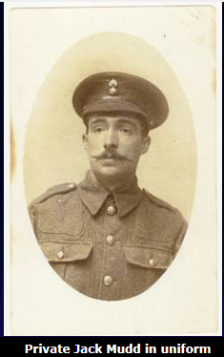
The private
Private Jack Mudd (2/4th Battalion, London Regiment, Royal Fusiliers)
and his wife Lizzie

Jack and Lizzie corresponded during the first years of the war, exchanging news and offering each other as much love and support as they could get on the page.

John William Mudd - better known as Jack - was a cockney from Bow in London's East end. In his absence his wife Lizzie held the fort, raising their children - a situation of which Jack was all too painfully aware: 'I often take your Photo out of my pocket and look at your dear face and think of the times we have had together, some lovely days eh love, and when I think again of some of the worry I have caused you it makes me only the more eager to get home to you to atone for all the worry and anxious moments you have had to put up with.' These words are taken from a heartfelt letter written home just four days before Jack's death.

He died aged 31 during the latter stages of the Third Battle of Ypres generally known as Passchendaele after the village and ridge which marked the high tide of the British advance - a place where thousands of British soldiers lost their lives. Ground conditions on that day, 26th October 1917, were very bad and many men were up to their knees in slime. It was reported that the mud made it impossible to bring in the dead and the wounded - one of whom was Jack. His body was never recovered and by the end of November Lizzie had received a copy of Army Form B. 104-83 telling her that Jack had been posted as missing.

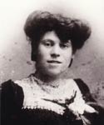
Early in December Lizzie received another form stating that the army had been 'regretfully constrained to conclude' that he was dead. His name is on the Memorial to the Missing at Tyne Cot Cemetery Belgium standing beneath the Passchendaele ridge.

We know that Lizzie married again, to a friend of Jack's who also served in the 2/4th Battalion and who was badly wounded. But she preserved Jack's last letter as loving testimony to their happiness and it was given to the Imperial War Museum, London,
by Lizzie's daughter.

Jack worked hard to reassure Lizzie about her plight as well as his own: 'I guess you have been worried with the air raids. You know dear it's hard to be out here fighting and yet your wife and children can't be safe. Still dearest don't worry, you have a 20,000 to 1 chance and God will watch over you as he has been with me ever since Lizzie Mudd, wife of Jack ©I've been out here.' But his cheerfulness did not completely mask his vulnerability; he asked for his family's prayers: '...so dearest pray hard for me and ask Marie for God will not refuse her prayers, she doesn't know the wickedness of this world'.

Jack also gave a revealing and sensitive description of the importance of friendship in the trenches: 'Out here dear we're all pals, what one hasn't got the other has, we try to share each others troubles get each other out of danger. You wouldn't believe the Humanity between men... It's a lovely thing is friendship out here.'

The overriding message of Jack's letter is his desire to get home to his wife and children and to give them all the love that they had missed: 'Please God it won't be long before this war is over, we are pushing old Fritz back, I don't think he will stand the British boys much longer and then we will try and keep a nice home. I will know the value of one now. Goodnight love God bless you and my children and may he soon send me back to those I love is the wish of your Faithful Husband xxxxxxxxx Jack'.
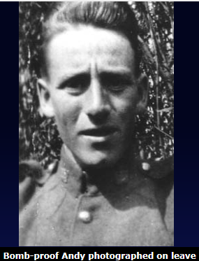
The 'canuck'
Private Andrew Munro, 'Bomb-proof Andy', 50th (Calgary) Battalion, Canadian Expeditionary Force
The Canadian Andrew Munro was born in Britain but had lived in Canada since the age of two. He was 22 years old when he joined the war as an infantryman, leaving behind his job as a bank clerk.
His steady outlook served him well and he survived the war to be discharged in 1919. Having said that, he made it through some 'tight corners' (as he put it) against all odds, and eventually became known in his company as Bomb-proof Andy.
Private Munro's letters home were less frequent than his British contemporaries' due to the length of time it took for correspondence to reach his family in Calgary, Canada - this must have been hard for him as he once wrote to his father '...a fellow gets lonesome and that's when a letter from home, above all, does wonders'. His letters show resilience but gradually weariness does set in. Nonetheless he was proud of his Battalion and Canada and constant in his written displays of affection for his family, including his little sister Connie who always got her own set of kisses.
What his correspondence does reveal is a healthy scepticism of the righteousness of the war and the authorities who shaped its destiny. But he was also aware of the system of censorship that was in place and had to curb his desire to give a full picture to his parents: 'I cannot give you much news Dad, as they are getting too strict, so I would rather you got a letter with little or no news than none at all.'
Often his requests are practical and typify the nuances of each soldier's needs in the trenches. While in training he writes to his father, 'Oh say Dad will you send me that safety razor and also some blades? The piece of "hoop-iron" the army issued me for the purpose of shaving is strictly on the hummer, so if you do not need that razor I could use it...It will be handier when we go to the trenches too for I guess a fellow has to be able to shave standing on his head there.'
Two years into the war he got a chance to express himself freely. In December 1916 he was issued a pass and returned to England to visit relatives. Without the censors looking over his shoulder he was able to write a long and frank letter home:
Now I am in England I am going to write you a few little things. Suppose you had an idea that we were on the Somme in the midst of the very heaviest of fighting, where the Canadians have won undying fame for themselves...but our losses are heavy indeed, although not to be compared with those of the enemy. The 50th of old is practically extinct, and there are only about 30 of us who are really "originals" left. Do not know how I managed to come through it. Was blown up once, buried once, and thrown down by concussion of bursting shells, and bombed by Fritz in the bargain. That was an awful day I had. I was not a bit nervous during it all, even when I went through humane barrage 3 times, but after I got back to billets my nerves could stand it no longer and I collapsed.
To add to this he described his frustration with the army's regulations: '...never once did the boys grumble. It is when we go back for a rest and buttons have to be polished etc...for inspections by some "big guns" who hand out lots of Hot Air, of which the boys have long since gotten tired.'
Munro was generally cheerful but even he admitted to an occasional fit of the blues. His courage and determination seemed to be strengthened by his pride in the Canadian troops and their reputation: 'Yes, the Canadians have a record that is second to none.'
By the time he was discharged in 1919 after training in the No. 6 School of Aeronautics, Clifton, Bristol, he considered himself 'quite "climatized" - [a] regular old soldier... Some of the boys call me "Bomb-proof Andy", but of course I know that our lives are in the hands of the One, who alone looks after us. We cannot help realizing it in a place such as this.'

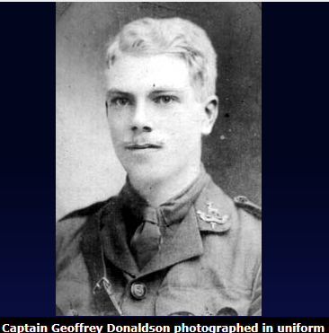
The captain
Captain Geoffrey Donaldson 7th (Territorial) Battalion of the Royal Warwickshire Regiment
Captain Geoffrey Donaldson was the only son of Dr Eben Donaldson of Londonderry (who died in 1904) and his wife. The abundance of condolence letters sent to Donaldson's mother after his death in 1916 is testimony to his popularity as an officer and civilian.
His correspondence is informed by his love of nature and the world's beauty - he was a botanist - even in the midst of war. Added to that, the collection of letters constitutes an account of life in the trenches and the effects of war on men of various ranks. Particularly notable in the letters is his good humour and insightful observation of humanity.
Donaldson was educated at Oundle School, a public school for boys, where he did well and was much loved by his fellow pupils and teachers for his frank and attractive personality as well as his academic ability. A fellow pupil wrote to Mrs Donaldson how her son had been an inspiration, a pioneer of botany who would have achieved so much; his housemaster mourned Donaldson and regretted that he would not be able to continue their great friendship when peace eventually arrived.
Before he enlisted for war, Donaldson was an undergraduate at Gonville and Caius College, Cambridge, and took a first class in part one of the Natural Sciences tripos. But he was one of the first to join the OTC and went straight to a training camp in Cambridge before he began his second year at university. Within two years he would find himself on the Western Front gazetted to captaincy. As Donaldson himself explained: 'On March 10th I became that very common product of war - a very young captain.'
He had a strong visual sense which enabled him to describe the battered wartime landscape: 'All that one sees looking through the periscope is a great waste of flat, but debris covered, ground like that behind our line with ruined buildings and shattered trees in the distance.' But he was always able to find hope and beauty there - describing the ruined churchyard at Neuve Chappelle he wrote:
In the churchyard stands a huge black Calvary with the figure of Christ hanging intact upon it, a silent reminder of the ideals of Christianity and I suppose, that just as that pathetic figure has been spared by the bursting shells and still remains there in that scene of desolation, so the ideals of Christianity remain unshattered too... The grass grows high round the dilapidated gravestones and everywhere there is a profusion of garden and wild flowers, poppies, roses, larkspur, monkshood... I enclose a piece of hysimachia from the Churchyard. I only wish photographs could be taken here. The ruined chateau with its fine Clematis-covered gateposts and Church and Calvary would make wonderful pictures. They impressed me more than most things I have seen.
His writing about war is on a par with better-known literary contemporaries such as Wilfred Owen.
His outgoing personality meant that he appreciated the camaraderie of his situation - of the Mess he wrote, 'It has certainly always been the "happy family" which the tradition of the regiment lays down it should be, and its influence on the well being of the battalion cannot be overestimated.' Others would say the same of him. He was fondly nicknamed Dunlop and the men always considered him cheerful and easy to respect. One private wrote to his mother: 'I am sure no one in the Battalion felt his death more than I did. I did so admire him, the way he threw all his energy and mind into a thing he loathed, simply because it was his duty was very fine, and the his calm, cool courage in the trenches, but when the time came for action, he simply blazed forth.'
If Donaldson loathed the business of war he did not complain about it. In his last letter home he remained resolute and determined to comfort his mother: 'I don't think anything will affect my nerves now, so don't worry about me, dear, because I shall pull through all right and I am strong enough to stand any amount of fatigue.' His courage was matched by an indefatigable sense of humour - describing the scene after an attack for example, 'There were a great number of dead rats lying about, killed by the gas, as they have no gas helmets.'
Not that he was insensitive to the plight of others; he understood that some men could not withstand the horrors of war and described neurasthenia with medical objectivity:
I hear that ------ is much better; he was absolutely exhausted and I had no option but to send ------ and him back, as it was essential that they should not be near the men while the sort of ague, which is the outward and visible sign of the disease, was upon them. I say disease advisedly, because it is a disease, which they themselves are really unable to prevent. It just depends on the way you are made. Some are unconcerned, others must collapse if there is a prolonged strain.
Yet however sympathetic he was to the problem, he still felt it necessary to make a distinction between the treatment of officers and privates: 'Some of the men of course had it too, but I allowed none of these to go back. An officer is a different thing, because on him depends so largely the nerves of men.' This is the harsh reality of World War One - the experiences of many men depended on their class and rank.
Captain Donaldson led his company over the top on 21st July 1916 in the battle of Fromelles, which was intended as a diversionary attack staged to draw enemy troops away from the Somme. He led in a gallant manner, piercing the German 1st and 2nd lines, killing the enemy and taking prisoners. Sadly, the battalion to his left failed to get across no-man's land and Donaldson's company was cut off. He was killed by a bomb thrown directly at him.

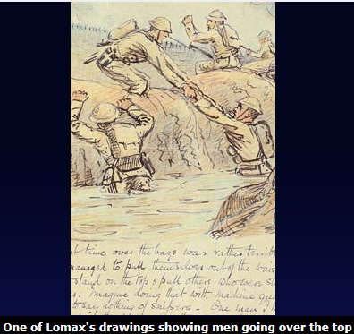
The army chaplain
Reverend Canon Cyril Lomax, 8th Battalion The Durham Light Infantry
Cyril Lomax graduated in History from Oxford and was ordained in 1895. He was appointed assistant priest of the Parish of Washington, Diocese of Durham, then two years later he became a rector. His involvement with the army began in 1900 as chaplain to the 4th Volunteer Battalion Durham Light Infantry (which was renamed the 8th Battalion The Durham Light Infantry in 1908) and his association with the 8th lasted nearly 25 years.
He did not enter the war immediately even though the 151st Infantry Brigade, to which the Battalion belonged, crossed to France on the 15th April 1915; no doubt he had a commitment to his parish and had to remain in Blighty. But in July 1916 he did cross to France and wrote about his experiences on the Western Front in vividly illustrated letters, some of which are now displayed in the Imperial War Museum, London. The Battalion also published one of his sketches in the Battalion history which describes how he liked to draw in his free time, when he was not offering spiritual guidance or general support to the men.
Lomax's letters are addressed to Doris Steinberg who may have collected them, but they were found in a second-hand bookshop and sadly do not come in a complete form - only those pages including images have survived. These nonetheless offer lively descriptions of trench conditions and life as a chaplain in World War One. In particular Lomax points out to his reader how important the giving and sending of letters was - an opinion with which most soldiers would have heartily agreed - '...thanks ever so much for your delightfully long letter. As a rule, I am a brute about letter writing, but not out here, things are so different. One is so utterly glad to receive a letter... You can have no idea how one looks for the post, and how disappointed one feels if there is nothing for one: I can quite understand the "lonely soldier" idea at which I once used to laugh.'
Like others, he described the psychological effect on some soldiers of the chaos of trench combat and the small variety of comforts that were available to the men:
There is an incessant thudding of guns in the distance to concentrate one's mind on the beastly shells. It becomes an obsession with some poor fellows who have been wounded or been through some hideous time in the trenches or the attack. The only antidote is preoccupation of some other kind, something to take the mind off the war. Well, what have we? Reading? A few papers now and again! A game of bridge sitting on the sides of ramshackle temporary beds, or on a soapbox! All the side shows of civilization are afar off, and we live a most primitive life...
And yet he was able to find small pleasures in the devastation around him - also typical of many men who coped with the trenches: 'The other day the doctor and I went out to gather blackberries to make what our miner cook calls a pudden.'
With an artist's eye he described the colour and shape of war in an almost impressionistic style:
Great gouts of flame, black smoke, stones and baulks of timber had been flying thirty feet in the air at least... When it was all over, out from what had been the thickest of it, waddled a tank, painted green and yellow, as [if] it might be rubbing its eyes and saying "Dear me, I believe somebody woke me! I think I must find a quieter spot."
And his sympathies were roused by the impossible mud:
Everybody too hates mud, but we bathe in it, wade in it, sleep in it and clods of it adorn the most secret recesses of one's clothes, books and papers. To see the poor brutes of horses straining through axle deep mud with the food for the hungry guns goes to my heart even more than seeing the unfortunate men coming out of the front line. The poor beasts have such a pathetic droop, look so patient, and miserable, and respond so bravely to some tremendous effort to suck a limber out of mud...
As a chaplain Lomax must have considered the uselessness and horror of war with more philosophy than most, although it was not uncommon for many soldiers, from privates to higher-ranking officers, to refer to God's purpose and seek an explanation for destruction on such a scale. Lomax was frank in his letters and did not shy away from detailed description of the hellish scenes although he did censor his own drawings:
If I wanted to make you creep I might have put a realistic foreground of dead Bosch and our own, fallen in every sort of attitude: some half buried by shell, others in the open. But the reality is too ghastly. There is none of the dignity of death - the flies and rats see to that. The impression left upon one is one of waste. Indeed the whole Country would admirably do as a picture of the material conditions of Hell. All that is pleasant and comely and decent and comfortable has been rent and torn away: all that is sordid, and ghastly and terrible remains. Of course not for one moment am I speaking of the quiet heroism of our average unassuming chaps who stick it all so stolidly, I am speaking of the physical conditions of life.
If he ever doubted God's purpose he certainly never rejected Christianity and remained faithful to the 8th Battalion as their chaplain after the war and was well-respected by all ranks.

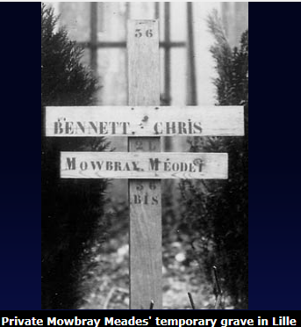
The conscript
Private Mowbray Meades, Machine gun section, 2nd Battalion Middlesex Regiment
Mowbray Meades was conscripted in 1916 under the terms of the Military Service Bill which was extended to include married men. He was 35 and shocked to find himself in active service. His letters home betray just how much he missed his family - his wife and children (one of whom was born whilst he was at war), and what a brave outlook he had been forced to adopt. Tragically, he died from pneumonia in July 1918, having been taken a prisoner of war.
In the Imperial War Museum archives is a photograph of his temporary grave at the Faubourg des Postes Communal Cemetery, Lille, and with it is a form from the Imperial War Graves Commission, undated, which offers the bereaved relative a chance to suggest a 'personal inscription or text'. There are no corrections or personal epitaphs recorded here - is it possible that Meades' wife could not bring herself to respond?
Meades describes the effort of adjusting to military life in the first of many letters to his wife. 'There are all sorts and conditions I can find here but the lot I came with are fairly decent chaps. It will take some getting into I can find, but expect eventually it will come alright... Don't upset and worry yourself unduly dearest, it will only make things worse for you... I hope the two little treasures have not been too upset at my leaving them. Poor little Chickie, she will miss me most, but not more than I shall them.'
Like many soldiers he felt the need to present a cheerful countenance to his loved ones back home. When Christmas came - and home seemed further away than ever before - he was still determined to remain upbeat:
Well, dearest, I know you will have been thinking a good deal about me today and wondering how I have faired. I thought about you all last evening and pictured what we should have been doing, listening to the Bells ringing in Xmas morning. When I awoke this morning my first thoughts were of the dear little girlies and I fancied I could see them running down to get their little stockings and bringing them up and turning them out the bed. Of course they hung them up, didn't they? I was with you too about mid-day and could see you all at dinner and imagined what your thoughts would be. "I wonder what kind of Xmas dinner Mowbray is having?" Well, dears, I can say I had the finest dinner today I've had in the Army. We had roast pork, potatoes and cabbage, Fig pudding, Jam roll, Xmas pudding and Jelly. Of course that was of our own procuring and not Army rations. The old Frenchman and his wife at the Farmstead sat down with us and there was 17 of us all told. She cooked the joint and vegetables for us and one of our fellows made the puddings. Of courses the Xmas puddings were yours and one of the other fellows' wives. The fellows wished "Good Luck" to the makers of them so I pass it on to you and hope you will enjoy their wishes.
31st July 1917 in the first day of 'Passchendaele' (Third Battle of Ypres) Meades was wounded - seriously enough to be sent home. He recuperated in Bradford and then Tipperary, Ireland. From Bradford he wrote, 'I wish there was some sign of an early finish to the war and no such possibility of my again returning, but we shall have to prepare ourselves for such an eventuality.' The early days, when Britons remained convinced that the war would be over by Christmas, were long gone.
The shadow of the war fell heavily on Meades, he had no delusions about the threat to his life - from Tipperary he wrote:
Arthur tells me Blanche had a brother killed out in France on August 5th and her sister's young man was also killed at the same time, so they will know what war means. Glad to say I am still feeling fairly well... Yes dearest I know I have your every confidence as well as your love, but you need never fear for one moment. You grow more dear to me every day and I have been indeed very thankful that I have been so blessed with such a treasure of a wife. As I am writing some soldier is amusing himself on the piano and the song above all others he is playing is 'Somewhere a voice is calling'. How painfully true I know that is in our case, and he preceded it with 'God send you back to me'. How earnestly we hope and pray that he will do.
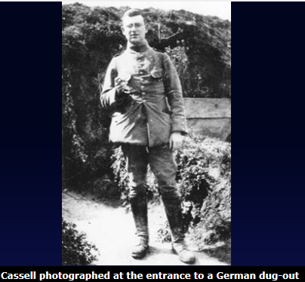
After Tipperary he recovered to return to the Front before the first of the great German offensives of 1918, during which he was taken prisoner. Mrs Meades received a letter from the Agence des Prisonnieres de Guerre dated 11th October 1918 telling her that according to lists despatched from Berlin on 5th September 'Pte Meades Mowbray 2/6 North Staffordshire Regiment born 5.10.81, of Chipping Norton, had died on 9th July 1918 in the Military Hospital at Lille of inflammation of the lungs'. Mowbray's earnest prayers had been in vain.
The German officer
Lieutenant F L Cassell, Infantry Regiment 143, 2nd Reserve Battalion, German army
When Archduke Franz Ferdinand, heir to the Austro-Hungarian empire, was assassinated in Sarajevo, F L Cassell was 25 and living near Berlin. In his memoir he recorded that 'Nobody wanted to believe that England would declare war.'
He was already a member of the 2nd Reserve Battalion in the German army and got his mobilisation papers immediately. He reported to Darmstadt on the 7th day of mobilisation. Like many other young men, in Britain and Germany alike, he was naïve about what lay ahead of him and enthusiastic, carrying the conviction of a German victory.
His training was limited and by October he was sent to the front on the day of his 26th birthday. He describes his first experience of combat: 'The next night we were alarmed and came, the first time for me, into fire. We were moved over dark meadows in zigzag, partly in open formation. Then across bridges and through hedges, without seeing more than the man in front of you. We overheard the buzzing and whizzing of grenades and shells and shrapnel and the nearby hissing and whistling of rifle projectiles...' But he quickly got used to frontline conditions and even considered dysentery a part of everyday life.
He became an NCO then vice sergeant-major. Others were promoted to Lieutenant but as he described the situation, '...the fact that I was Jewish made it impossible for the training officers to recommend it'.

Despite circumstances, he remained patriotic and described new enthusiasm after victories in the winter battles on the Eastern Front. Eventually he was promoted to Lieutenant, against the rules, and was even decorated with the Iron Cross. He was pleased to share the news with his parents - 'this was one of the finest moments the war brought me. I was proud of it and still am'.

His experience was improved, as in the case of many British officers, by camaraderie in the Mess. He also had an orderly and a batman and he was very fond of both. Surprisingly the war offered him opportunities; for example he learnt to ride. 'The horse had as little fun as me. I had not yet learned English trotting, and when the order came, the horse knew, but I did not and trotted German. After half an hour the toughest beef steak would have become tender under my saddle. But oh my buttocks!' He also took the opportunity to get married whilst he was wounded and on leave.
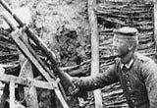
He seemed to exercise some control over his war career, procuring a position in the War Office so that he was no longer in action on the front. He was finally demobbed in 1919 when the 'Reich was broke'.
A German sniper, photographed by Cassell ©Of course Cassell's life was to change drastically with events to come. On 9th November 1938 (Kristallnacht) he was forced to leave his home by the Gestapo and herded into a nearby courtyard where he learned that 'all existing Jewish shops had been destroyed and set on fire'. He was separated from his family and put on a train, destination unknown. Eventually he arrived at Dachau where he spent three weeks before being discharged after his wife had pleaded his case on the basis that he had served Germany in World War One and was wounded three times. After a second arrest and detainment in various prisons he was transported to Konstanz which was much more civilized than Dachau, but nonetheless very frightening. His final release was secured by a Jewish lawyer who had to pay the authorities 15,000 Swiss francs.
Cassell left Hamburg on May 16th in 1939 having had his fortune (a family business) confiscated. When, 15 years later, he sought compensation for his treatment under the Third Reich, he records that he received only 'cca £150. For the time I spent in Dachau I was compensated with five Deutsch marks per day.'
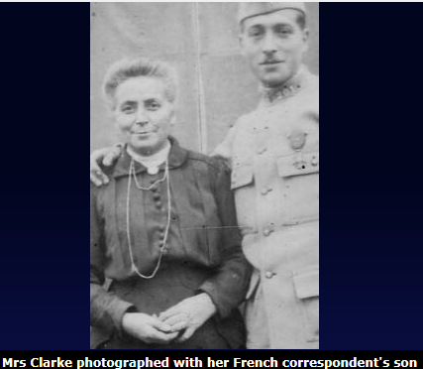
His arrival in Britain led to further imprisonment as an alien in Camp Douglas, Isle of Mann, where he was held for five months. Despite initial hostilities, he spent the rest of his life in Britain and wrote his memoir in the 1920s then improved and extended it in the 1970s before submitting it to the Imperial War Museum with a collection of photographs which he took in the trenches.
The mother
Mrs T Cooper Clarke, mother back in Blighty
'My Darling, We are so glad to hear from you although your notes contain so little news they convey to us what we chiefly want to that is that you are safe.' Words from a final letter to her son, Joe, sent on 16th March 1918. The letter was returned to sender with 'MISSING' written in red ink across the front of the envelope. Although this was standard procedure, it must have been a painful experience for Mrs Clarke to be alerted so abruptly to Joe's possible death.
For over a year Joe had been writing home, addressing his letters sometimes to his mother alone, sometimes to his 'Mum and Dad', sometimes including his sister Eileen who also received one or two letters of her own. It was Eileen who kept his correspondence and bequeathed them to the Imperial War Museum.
Joe was 18 when he joined the army as a Rifleman - not yet old enough to go to France, but old enough for training. He kept his mother informed of his progress in the Training Reserve in Northampton - 'From now on I will write regularly every Sunday evening,' - and described the experience with a positive attitude: 'I still enjoy soldiering very much and feeling better than I have felt for many a day.'
Although Joe admitted that he was looking forward to returning home for leave, he did not express any reservation about joining the war on the Western Front. In fact, he was itching to put his training to the test: 'Another draft of our chaps went to Harwich on Thursday last. A considerable number have now been sent and I would have gone too - had I been two months older.'
His letters were straightforward and cheerful with references to chums, meals and the temperamental state of the weather - as well as more detailed descriptions of what was expected of a Rifleman. Affection for Gyp, the family dog, was shared by the whole family; Joe wrote: 'So Gyp misses me does he? He is a funny chap and I do not suppose he will recognise me in khaki.' His mother responded, in her final letter, 'I think Gyp missed you. He runs up to every soldier he sees about your build and sniffs.'
Then on 1st March Joe finally wrote to say, 'We are off tomorrow Sat at 6am... I am feeling fit and well to see Fritz.' And in two or three very short notes he referred to his movement through France billeted in a barn one night. Mrs Clarke replied, 'Not a very comfortable place a barn but better I think than some of the places over there that I have heard of... We are so glad you feel well and hope you may continue so... What do you think of France. Can you remember your French?' She signed off, 'God [sic] bye dearie and God bless you - Love from all your afec. Mother'.
Within 40 days of writing that final letter, Mrs Clarke's son died of dysentery as a prisoner of war in a German field hospital. But it took until 15th July 1918 to discover the truth. Her determination to find out what happened and her reluctance to believe it are sad testimony to a mother's love.
She wrote letters to the King's Royal Rifle Corps, to the Red Cross, to the War Office and to a family friend, Lieutenant Kerwin, based at Le Havre. Kerwin met Joe briefly on his arrival in France and responded with great sensitivity to the family's fears for his well-being.
I personally telephoned to Head Quarter Casualties and spoke to the LAG himself.... He has promised to let me know tomorrow afternoon, but up to the present he has no news of Joe, so we must look on the bright side, as no news is good news. But, old sport [referring to his Joe's father] I'm not going to beat about the bush, you ask for news and I've done all I can and would willingly do more if I could. The news is this, Joe's battalion I understand was in the thick of fighting and there is still hope that is safe, or at most a prisoner, but the LAG said their casualties were heavy which included many missing.
On 17th May the family received a hasty postcard saying, 'Have good cheer. Made enquiries. Joe is all right. Will explain in letter later. In a hurry now.' But the Agence International des Prisonnieres de Guerre could shed no light on Joe's whereabouts in a letter dated 18th May.
Finally, on 15th July 1918, the Comité International de la Croix-Rouge sent the following: 'We are grieved to inform you that the following report appears on lists despatched from Berlin: [in red ink] 7.6.18 Rfm 41712 3rd R. R. R, died 22.4.18, result of dysentery at field hospital. Cugny. Buried in cemetery there, 222...'
Despite the news, Mrs Clarke continued her search and received in December 1918 a list of repatriated prisoners from the same battalion as Joe, enclosing their addresses. She wrote to all three and all three replied. One particular letter from Mr Powell suggested empathy for a mother's connection with her child: 'We had a rather rough time and fellows as I no [sic] for a fact were dying from this dysentery but I hope sincerely that you hear very shortly of him being alive. I am sure you are putting me to no trouble whatever I would only be glad to help you as I no [sic] what a Mother feels towards her son and also how my own mother was. If you do hear from him I should be glad to no [sic] if you finally let me no [sic]. I am, Yours Truly, Rfm E Powell'.
Still not satisfied that Joe was dead, Mrs Clarke put an advertisement in The Daily Sketch 'concerning a missing soldier'. The editorial staff informed her that a photograph could not be included. When she did finally accept that he was buried in France, she arranged through a French correspondent to have his grave tended. Then in 1920 Joe's body was exhumed and moved to a British Cemetery.

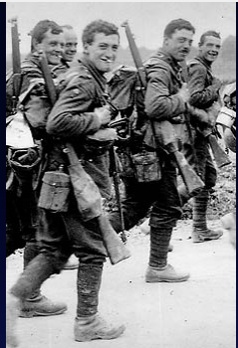
The boy 'pal'
Private James Tait, 10th Battalion East Yorkshire Regiment
James Tait joined the 10th Battalion East Yorkshire regiment - known as the Hull Commercials - on 19th April aged only 15 - clearly, there was no need to show a birth certificate before joining up. Probably inspired by the general belief that the war wouldn't last long, and carried along in a tide of patriotism (reflected in local support for the pals battalions raised in Hull between September and November the previous year), he had no concern that he was underage. Like many others at the time, he was keen to take a crack at the 'Prussian bullies' so he enlisted along with his step-brother Frank Cocker. Many men were drawn to enlist with the Pals and Commercials battalions in the hope of being at war together, but James was separated from his step brother. Unlike Frank, he survived action on the Western Front.
James was born in Newcastle in 1899, son of a tobacconist turned travelling inspector. When his father died James' mother remarried. He left school aged 14 to work for a wholesale tobacconist before he took a job as a stock clerk with a firm of ship chandlers. The opportunity to go to war may well have represented an enticing adventure and Tait's diary has a formal but romantic tone suggesting that he hoped to turn some of his memories into a publication - or at least have an audience for his writing.
After six months at a Depot co. at Hornsea and Pocklington, Tait spent nine weeks in Egypt before he was transferred to the Western Front. He was excited by the prospect of visiting foreign lands and described the atmosphere on board the troops ship: 'Dec 11th '15 - Dawn of a glorious day - sea calm and a few fleecy clouds relieve the monotony of the deep blue sky. I am from today to be a permanent Mess Orderly during the voyage. The band plays for the first time on board, and everyone is enjoying the journey now. We sit up on deck as late as possible, as it is a most delightful star-light [sic] evening. Singing is taken up in general.'
Obviously unprepared for what he was about to experience, he nonetheless displayed the same energy and clarity of thought as he described conditions in the trenches, and remained true to his word - always optimistic: 'Still raining. Troops in very bad condition. We are covered from head to foot in mud. As a rest we spend three hours in the dug-out which is a delightful treat.'
If he had a criticism of the war it was about the quality of training and the attitude of some of the officers above him: 'Complaint has been made by the officers that we are writing too many letters. It has been hinted by them that we are allowed too much time. Are we a navvy's Batt. or a commercial? A most unnecessary complaint surely could never have been harboured. We are entitled to our own time at night and as literature is very scanty what have we to occupy our time with? What delights us more than communicating as much as possible with the old land?'
When his mother and step father applied for his release, pleading that he was underage, the War Office made no difficulties and arranged for his return to civilian life. Although he regretted leaving his 'pals' behind, he was very glad to be going home. But this didn't stop him joining up again in September 1917 once he was legally old enough to enlist. He joined the Durham Light Infantry and was drafted to the 7th Battalion.
By April 1918 he was back in France and was lucky to survive the third German offensive which began on 27th May 1918. Tait's diary describing his second phase in the war had had to be abandoned with his large pack during the fighting but he recounts his experience in a short memoir. His battalion as Pioneers were positioned to the rear and were not caught up in the fighting until the second day of the German retreat. Even so, there were heavy British casualties and James was once again lucky to escape.

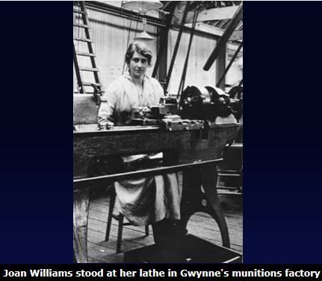
The munitions worker
Miss Joan Williams, munitions worker
Like many other women living in Blighty Joan Williams wanted to make a contribution to the war. The idea of working in a munitions factory came in 1915 with the news that her cousin in Bath had started to make shells. As she lived in London, Joan decided to offer her services to a factory in Chiswick situated on the banks of the Thames, and then wrote a lively memoir recounting her wartime work which she titled A Munitions Worker's Career at Messrs Gwynne's, Chiswick - 1915-1919.
Her decision was a spirited one; unlike most of her co-workers she was upper class and accustomed to being waited on. She was also aware that as a woman she might have been disadvantaged: 'I believe the men were always very jealous of the women doing the skilled work' but she notes that she experienced no problems and admired the leadership of her foreman Mr Baker who was 'of course... only too ready to teach me anything and anyhow it would have been ludicrous for anyone with his degree of skill to be jealous of any women and I don't think many men who knew their job and did it well really minded the women.'
Joan worked at the lathe - usually a 7ft Drummond - and although she felt very nervous on her first day she took to her new life straight away and enjoyed plenty of job satisfaction. 'I don't think any worker can have enjoyed their work more than I did, even though they attained a higher degree of skill and did far more important work. When I was on an interesting job it was nothing to leap out of bed at 5.15 on a frosty morning and I almost danced down Queen's Road under the stars, at the prospect of the day's work before me.'
Her background caused no real obstacle to her happiness either: 'A good many of the workers... had never come up against the upper classes at all and had very exaggerated ideas about them... Most ladies were to them people who "drew away their skirts" on encountering any working people, so I was very glad when they found it was quite possible to make friends with the despised class.' She was less impressed, however, by one fellow worker who 'was very free with her "Damns" and fond of airing explosive views'. Joan did not approve of this particular worker's attempt at creating division between union and non-union workers.
The memoir offers insight into safety regulations in munitions factories - she describes excellent first-aid facilities and organised procedures at Gwynne's. However, there were hazards. Women working in larger munitions factories were known as Canaries because they dealt with TNT which caused their skin to turn yellow. Around 400 women died from overexposure to TNT during World War One.
Other hazards were more obvious and minor problems were common. Although production at Gwynne's did not involve TNT, Joan herself recounts that grit from the grinding machine got into her eyes: 'I didn't take much notice at first but at the end of two days had to go to the hospital and have it scraped. It was quite a simple painless process but by that time both my eyes were so inflamed I could hardly see and I had a weird journey home, running a few steps and then being forced to close my eyes for a bit till they'd recovered enough to run further. I expect the passers-by thought I was a sad case of intoxication.'
In 1919 she was discharged and presented with a gift - an inkpot, lid inlaid with tortoiseshell - which 'surprised and touched' her. In conclusion she added her Managing Director's parting testimonial: 'I can only say that your attention to your work, your energy and perseverance were an example to the girls employed in the factory, and it was due to you, and others like you, that we were able to get such wonderfully satisfactory results from the large number of girls (some 1,000) that we employed at Chiswick, many on really difficult operations.'

